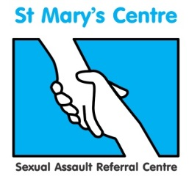

Forensic and Medical Examinations for Rape and Sexual Assault (FMERSA) 2023
Blocks A,B and C delivered online
Block D in person at University of Manchester Innovation Centre

This two-module course presents doctors and nurses with the opportunity to train towards conducting forensic medical examinations of rape and sexual assault victims, under the direction of the UK’s longest established sexual assault referral centre.

The course includes the medical, psychological, social and legal aspects of rape and sexual assault, focusing on the forensic medical examination, the collection of evidence, statement writing and testimony at court. The curriculum covered will help clinicians prepare to take the Membership or the Licentiate exam of the Faculty of Forensic and Legal Medicine.

Module One – Principles

This module provides a comprehensive introduction to the forensic medical examination, including classifying and documenting injuries. The wider criminal justice context of police and legal processes are also explored, as well as forensic science, ethics, child protection, statement writing, and social and psychological issues.

Module Two – Practice

This module provides a deeper level of detail around forensic medical and medico-legal aspects of work with rape and sexual assault. With a strong focus on the practical, the module includes paediatric examination and role of the professional witness. Further subjects include criminology, forensic odontology, effects of drugs and age, vulnerable adults, psychological effects and advanced legal issues including statement writing and court role play.

Dates for 2023
Module 1 |  | Module 2
Tuesday  Wednesday  Thursday | January 17th  January 18th  January 19th | Tuesday  Wednesday  Thursday | September 5th  September 6th  September 7th
Tuesday  Wednesday  Thursday | March 7th  March 8th  March 9th | Tuesday  Wednesday  Thursday | October 10th  October 11th  October 12th

Fees
£1,950 per individual module. Booking both modules reduces the fees to £3,700.
For more information and to book your place on this course please contact:
josh.edgar@mft.nhs.uk
0161 276 6515

